**2.2.6 Data Visualization**

**Data exploration and visualization**

Functional Requirements-

Use Hive Query and Hive Visualization tool.

1. Find the top 20 zip codes(hint: branch_zip) by total transaction value

2. Find total transaction value for each transaction type by Quarter in 2018

Hint: Find quarter from 'creditcard' table using month or use 'time' table if you already added transaction_id column there.

***// Dropping table if its there -***

drop table test;

***//1. Find the top 20 zip codes(hint: branch_zip) by total transaction value***

***// Creating temp table to be used for visualization***

create table test as select a.branch_zip ,sum(b.transaction_value) as TotalNumberOfTransaction

FROM cdw_sapp_d_branch a

INNER JOIN cdw_sapp_f_creditcard b ON a.branch_code=b.branch_code

group by branch_zip

order by TotalNumberOfTransaction desc limit 20;

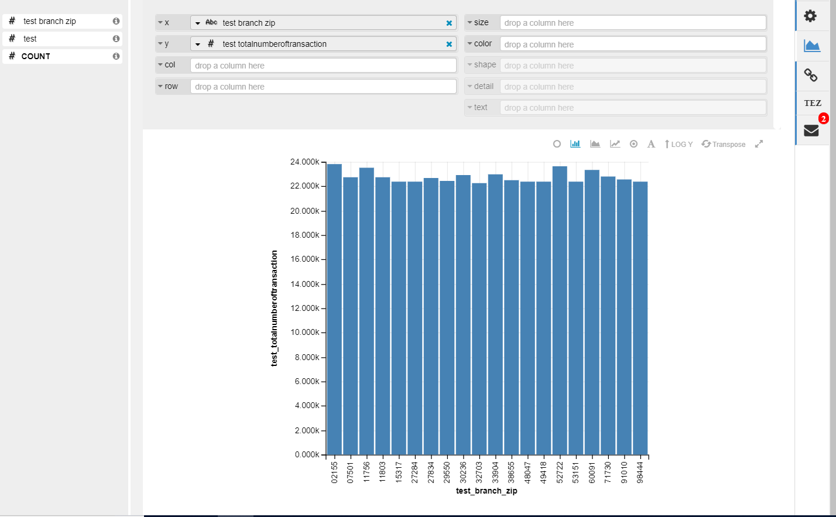

***// Dropping table if its there -***

drop table test2;

***//1. Find total transaction value for each transaction type by Quarter in 2018***

***// Creating temp table to be used for visualization***

create table test2 as select a.transaction_type,sum(a.transaction_value) as TotalNumberOfTransaction,b.quarter

from cdw_sapp_f_creditcard a

join cdw_sapp_d_timeid b ON a.transaction_id = b.transaction_id

group by a.transaction_type ,Quarter;

